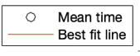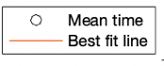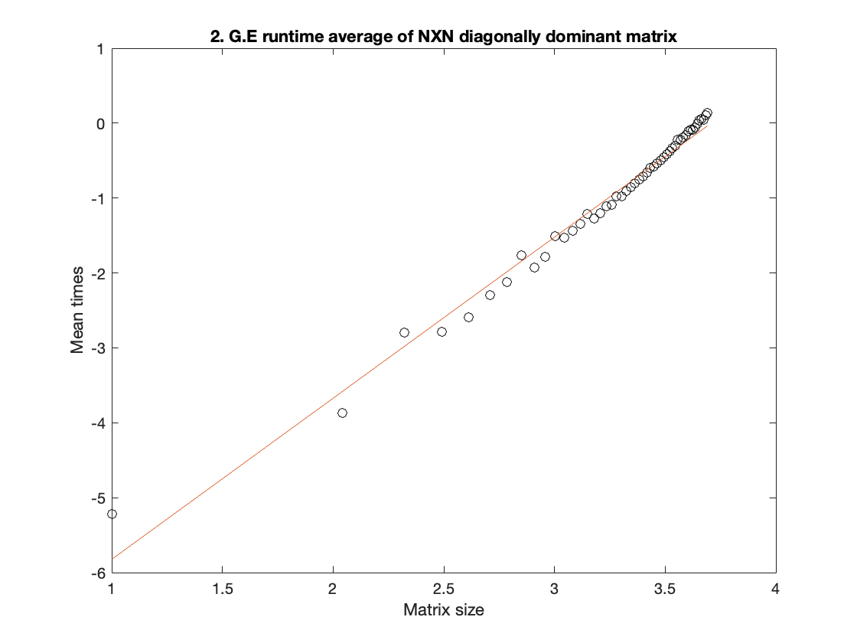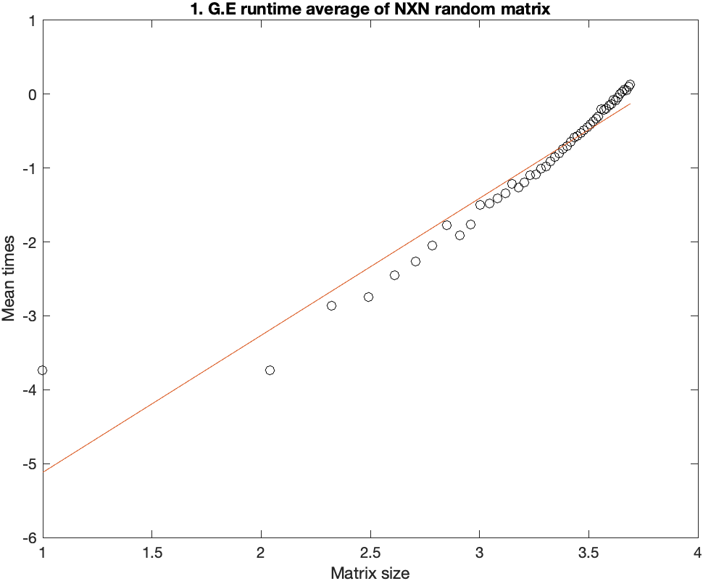

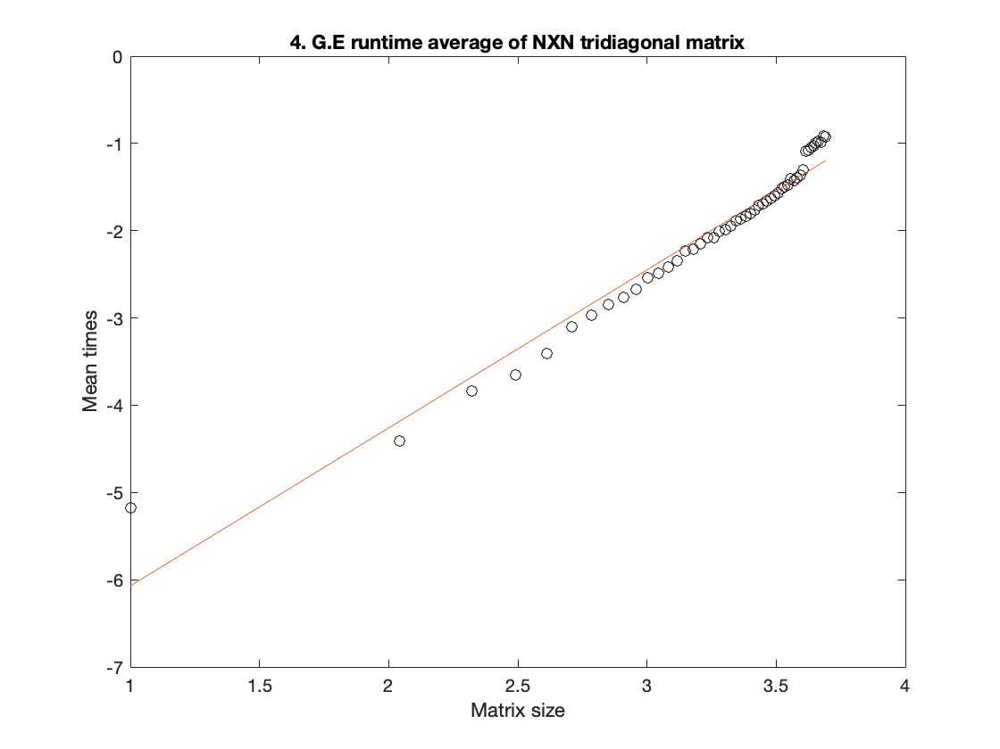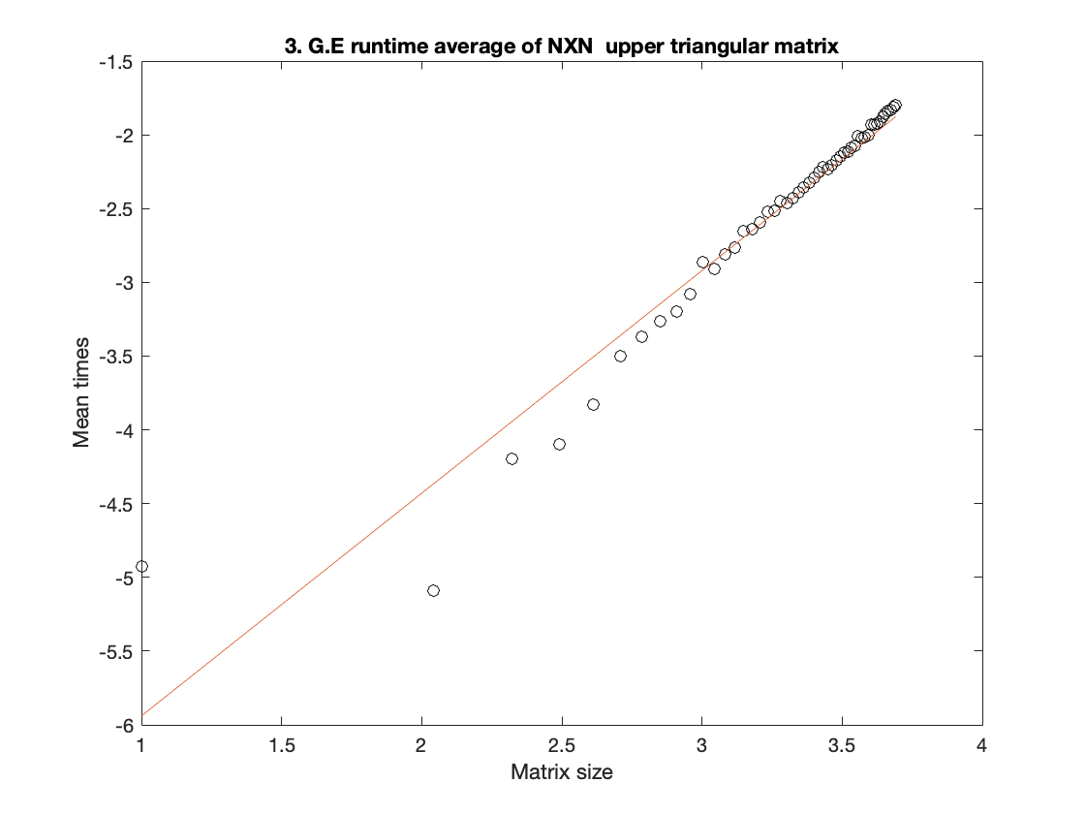



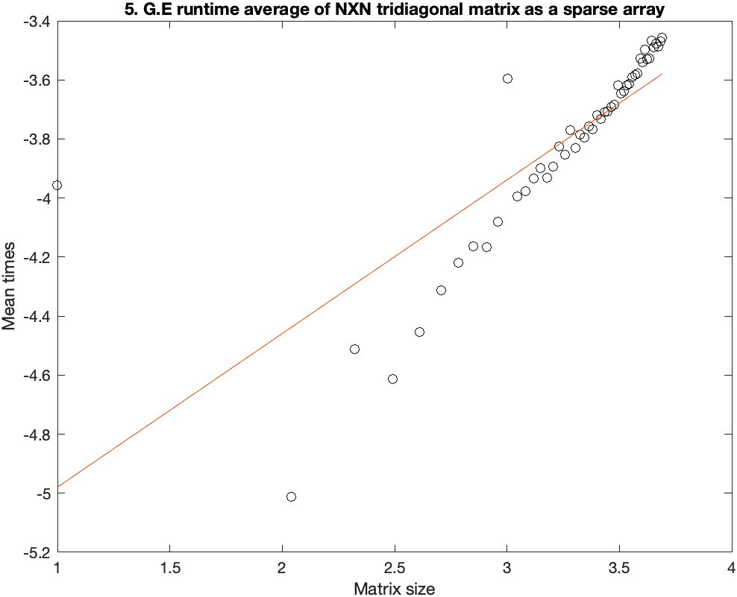

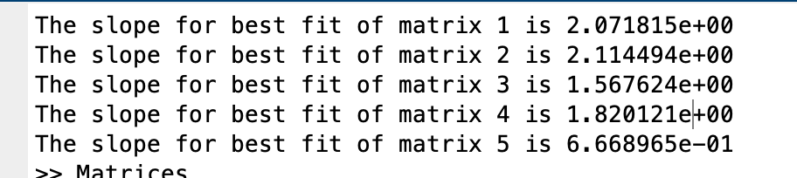

My matrix size ranged from 10 to 5000 with the stepsize of 100 and number of trials is 50.

The slope of the lines is the rate of change of time it takes to perform gaussian elimination with respect to the change in the size of the matrix.

Time complexity for gaussian elimination in random matrices is O(2/3 n^3), taking the log makes it 3\* log n where 3 is the slope of the line. The slope we get is significantly smaller than that because of the limited size of the matrix but with a larger matrix size, it should be approximately 3 as opposed to the slope of 2.0718.

For upper triangular matrices, since there it is already in row echelon form, finding the solution only involves backward substitution which takes O(n^2) time and taking log would be 2\*log n. The slope for the same is 1.56 which is very close to our expected value.

For diagonally dominant matrix, the slope turns out to be a bit less than that of a random matrix, approximately 2.11449. This is because there are no row exchanges which saves computation time and reduces the number of flops to O(c n^3) where c is a constant < 2/3. Taking log=> c \*log (2/3)

1.5676 < c < 3